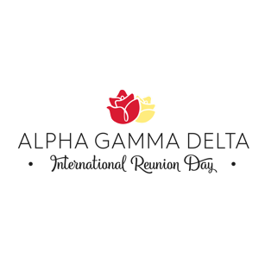

International Reunion Day – Sample Program

- Greetings and introduction of the head table and special guests – Mistress of Ceremonies
- Grace – Song Leader
- Lunch/Dinner/Tea
- Reading of the Fraternity’s IRD Speech by Melissa Jacobson James, IVP-A
- Guest Speaker (May choose either reading or speaker)
- Local Achievements – Collegiate President, Chapter Advisor or Alumnae Chapter/Club President
- Fraternity Achievements – Collegiate President, Chapter Advisor or Alumnae Chapter/Club President
- Collegiate Scholarship Award – Chapter Advisor, Academic Excellence Team Advisor, or Vice President-Academic Excellence
- Other Collegiate Awards – Chapter Advisor or Chapter President
- Recognition of 25-Year, 50-Year, 60-Year and 70-Year Members – Alumnae Chapter/Club President or Vice President
- Recognition of recipients and/or presentation of Alumnae Recognition Awards – Alumnae Chapter/Club President
- Recognition of wearers of Honors of Epsilon Pi – Alumnae Chapter/Club President or Permanent Secretary
- Talent of Leadership Award (if applicable) – Collegiate President or Alumnae Chapter/Club President
- Chapter Roll Call
- Announcements – Mistress of Ceremonies
- Pledge of Faith – Song Leader
- Farewell – Mistress of Ceremonies

